**INCREMENT - 2**

**Group-5**

**L V Sandeep Bathina**

**Ramakrishna**

**Vidhi Shah**

**Pushing the data to the SOLR:**

1) write a Restful web service to push the JSON file to the SOLR

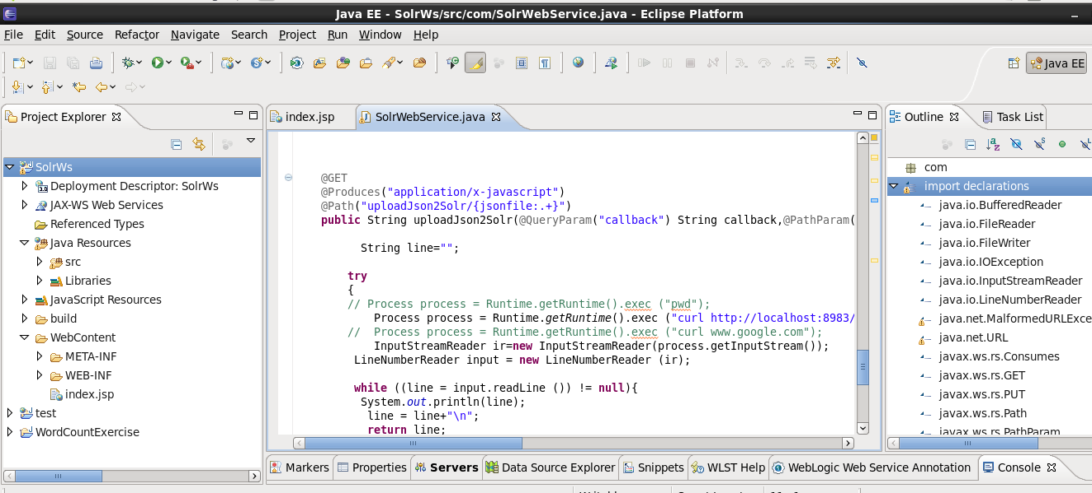

2) Now export the web service to war file and deploy this service on to the Glassfish server

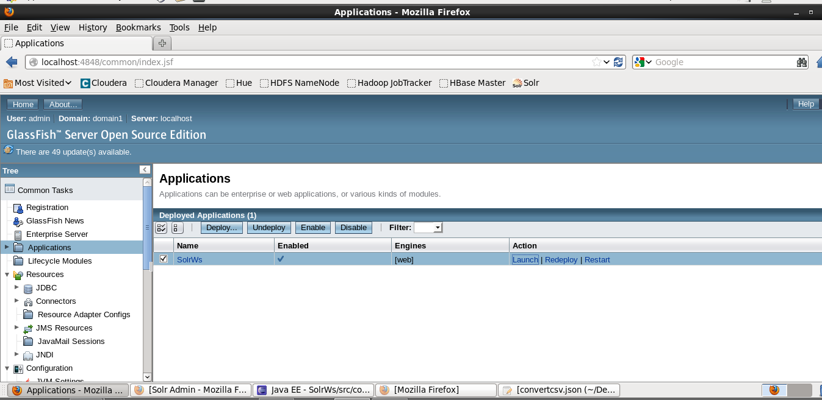

3) Convert the text file of disease information to the JSON format as below

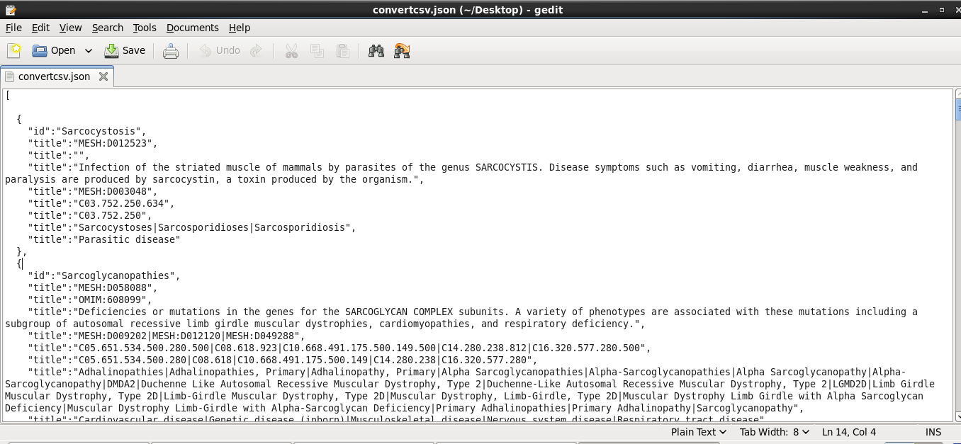

4) Run the service by http://localhost:8080/SolrWs/jaxrs/generic/uploadJson2Solr//<Json file path>

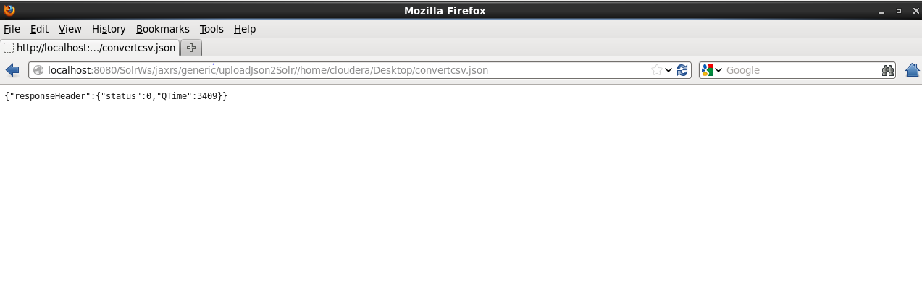

5) Here a total of 11824 disease information got stored in the solr as below.

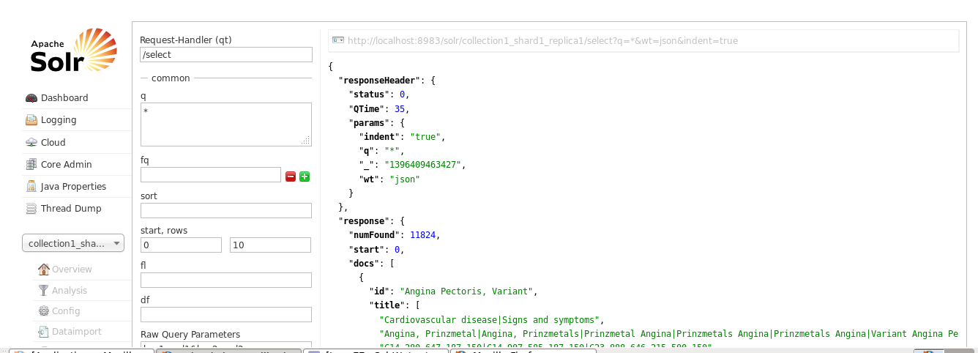

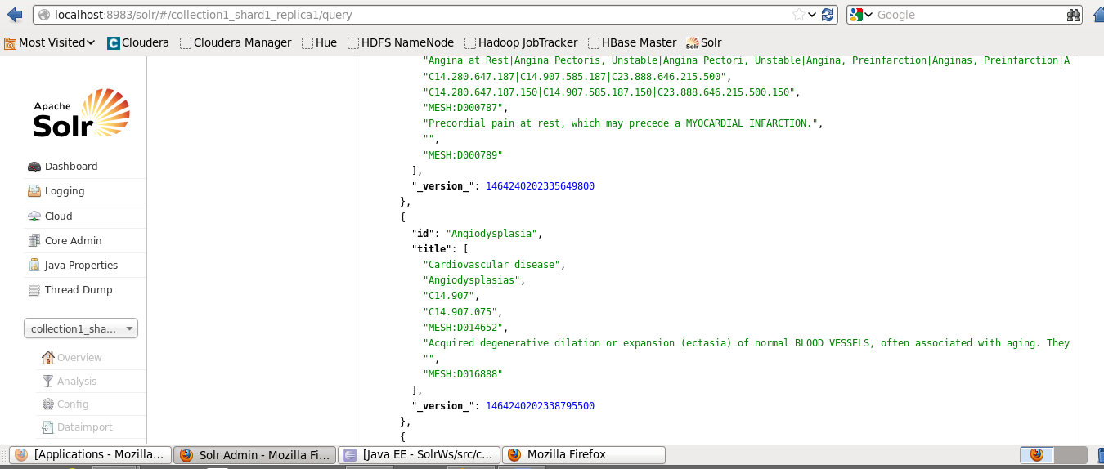

**Retrieval of data from SOLR to the User Interface:**

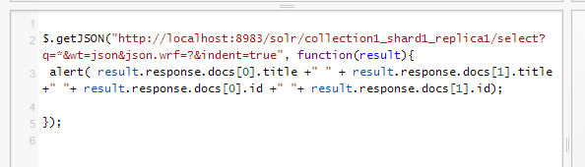

**Result:**

We will get the result for first two ids and titles of the solr output.

**Map Reduce Algorithm:**

**Run the project**

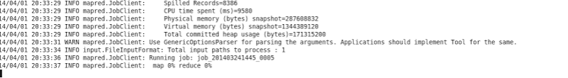

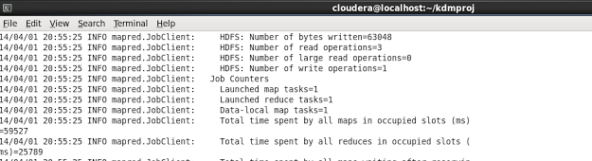

Got some error here we are working on it.

